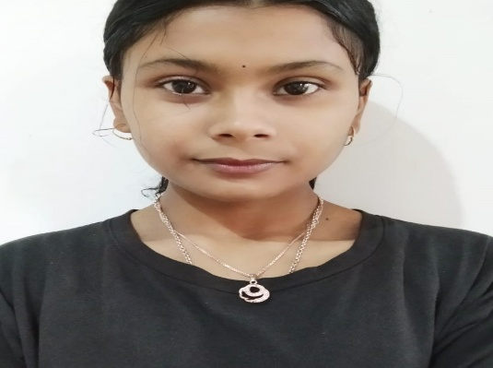 |  |  | ANAMIKA BHATTACHARJE
contact  Kolkata ,India  Pin - 700124  +91-6900918265  anabxj9@gmail.com  LANGUAGES  English  Hindi  Bengali  SKILLS  Python  SQL  React.js  Machine Learning  Cloud Computing  INTERESTS  Passionate about technology and data-driven problem solving, while enjoying dancing and crafting to enhance creativity communication. |  |  | Profile  Experienced Python Developer Intern and current BCA student with strong skills in Python, Java, and full-stack development. Proficient in IT hardware, software installation, and frameworks like Django, React, Angular, and Spring. Successfully contributed to real-world development projects in collaborative environments. Eager to further enhance my skills and build innovative, high-performance software solutions.  EDUCATION HISTORY  Bachelor of Computer Application, June 2024 - June 2028  Brainware University  Score: 9.20 SGPA  Class XII(Science) , May 2021 - March 2024  Pranab Jubilee College  Score: 59%  WORK EXPERIENCE  Academic Researcher, IEEE Conference (PCOD–ML Study)  - Worked on PCOD-related gene studies using machine learning, including data preprocessing and model training.  SIH Hackathon (Smart Tourist Travel System)  - Developed a tourist travel system for best-route selection with a focus on safety and optimization.  AI-Powered Health Assistant (Academic Project)  - Led development of an AI-based symptom checker with severity analysis, doctor referrals, first-aid guidance, and personalized health recommendations using user data and location factors.

